File Permission Task
Create a file with .txt extension (/home/demo.txt).
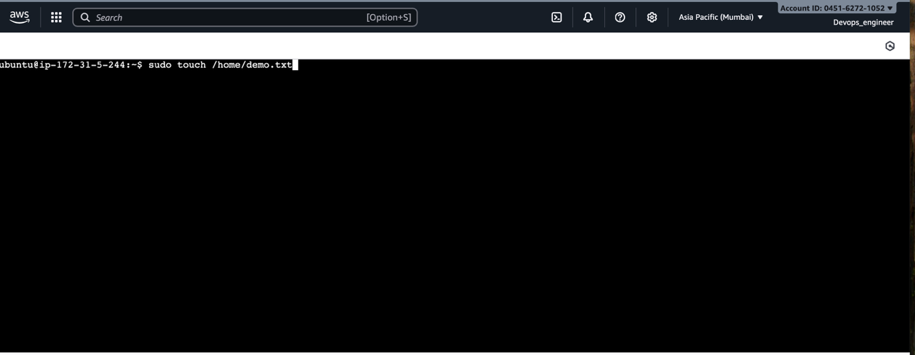
Change the permission set of that file, so that any user can read it, group can read/write & owner can read/write/execute it.
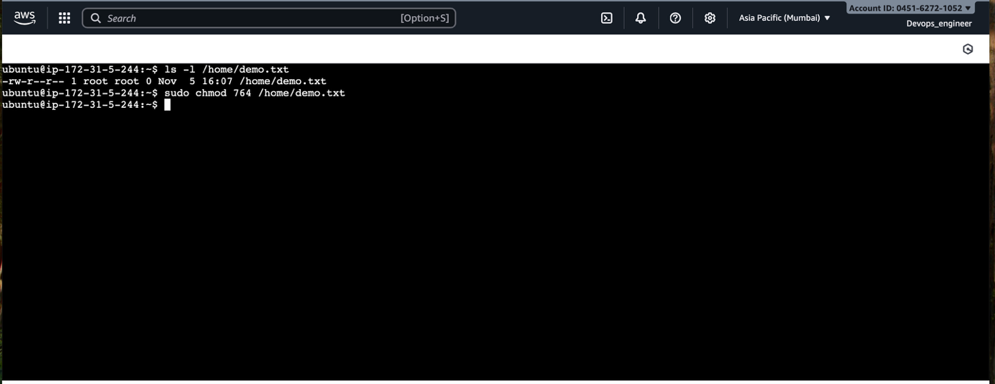
Output:
